Exercise 2

Step 1: From the virtual machine’s exercise 1 we press settings and we looking for system to change the order to boot: Optical before floppy.

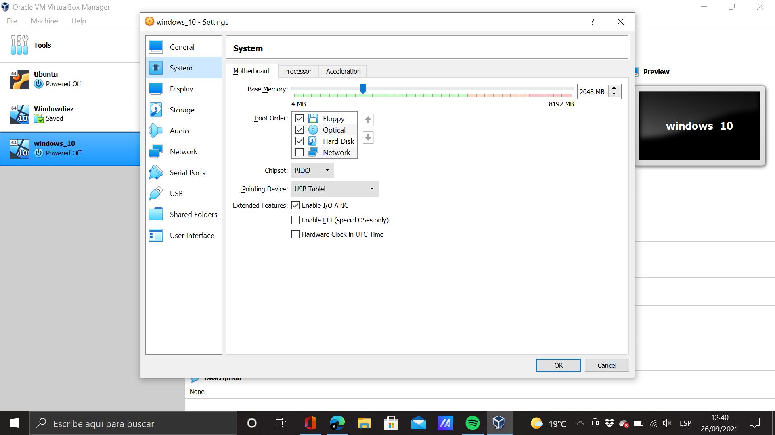

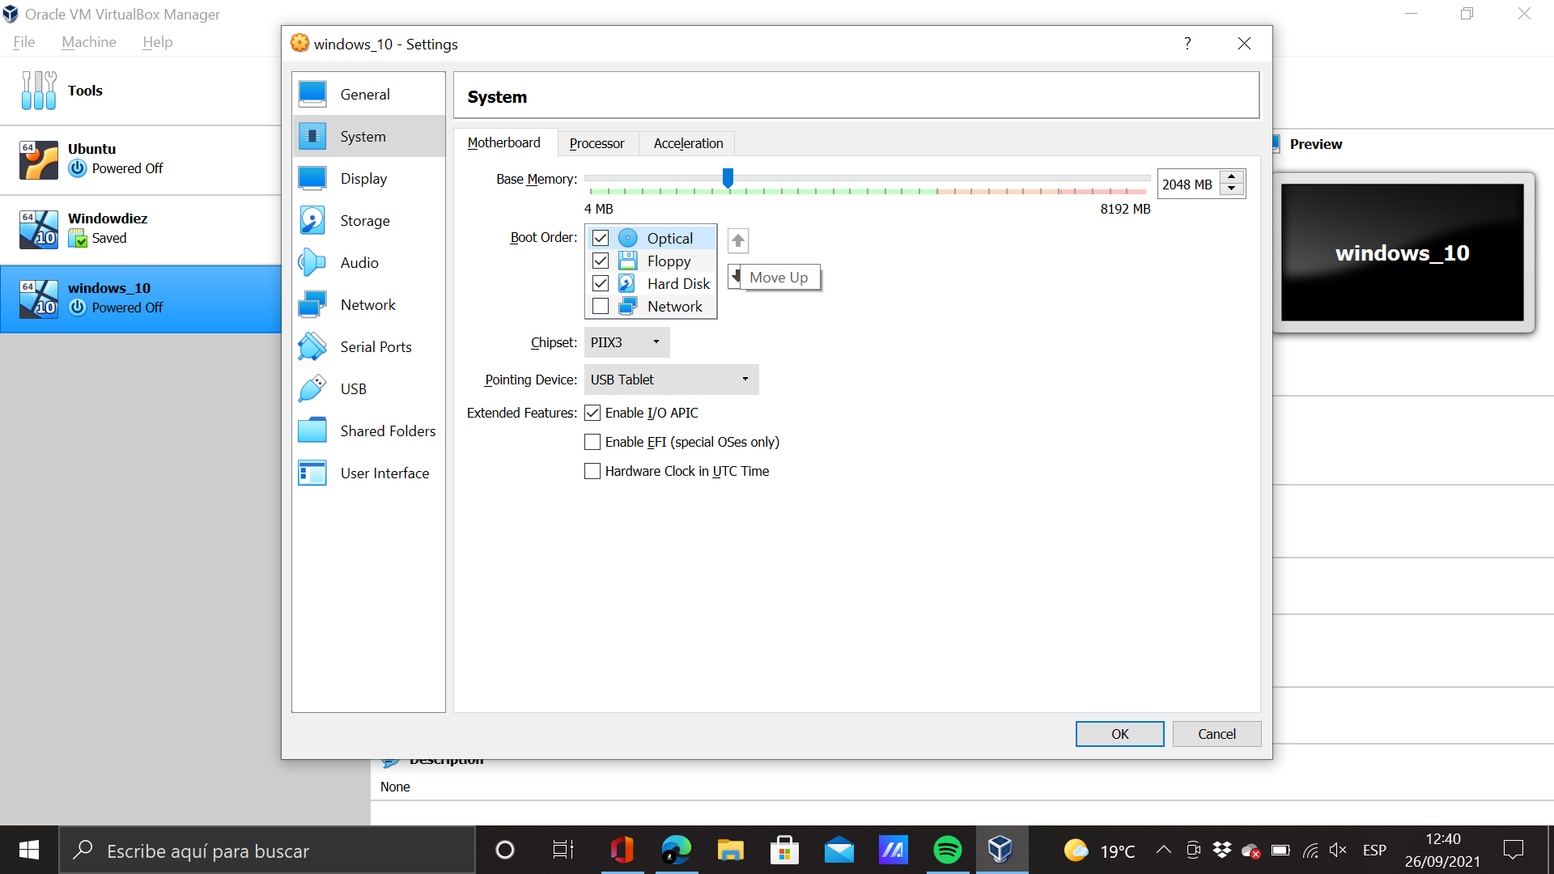

Step 2 Now we need to put our windows’ ISO file to start our OS. So we put our ISO file in storage selecting the empty cd.

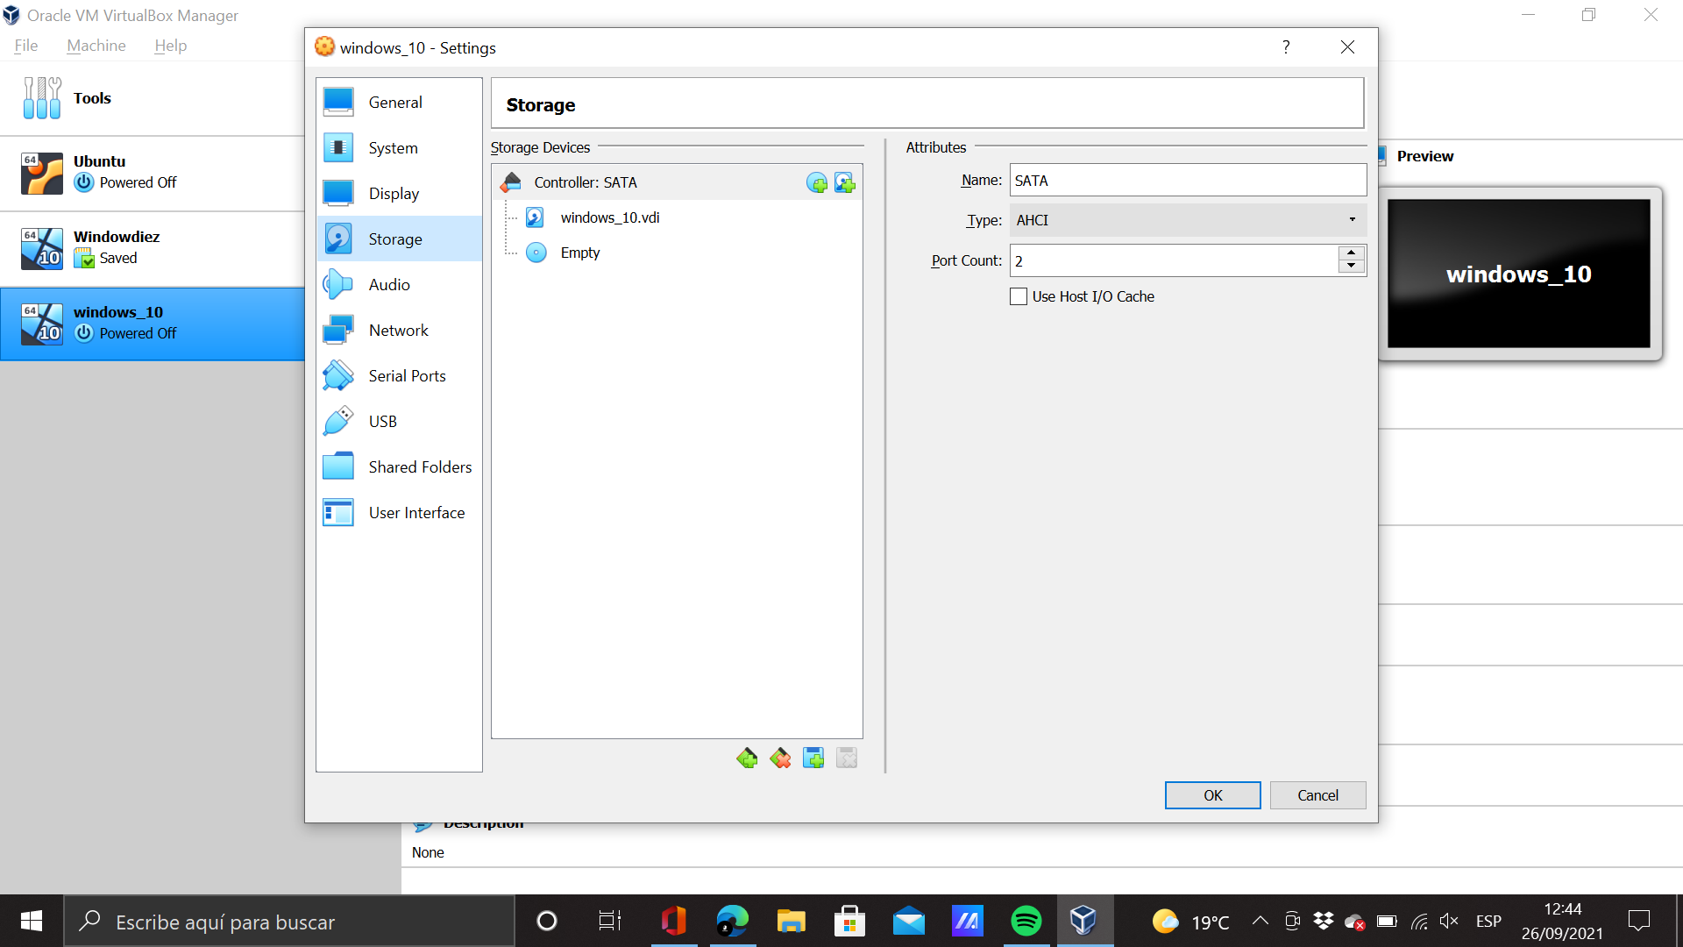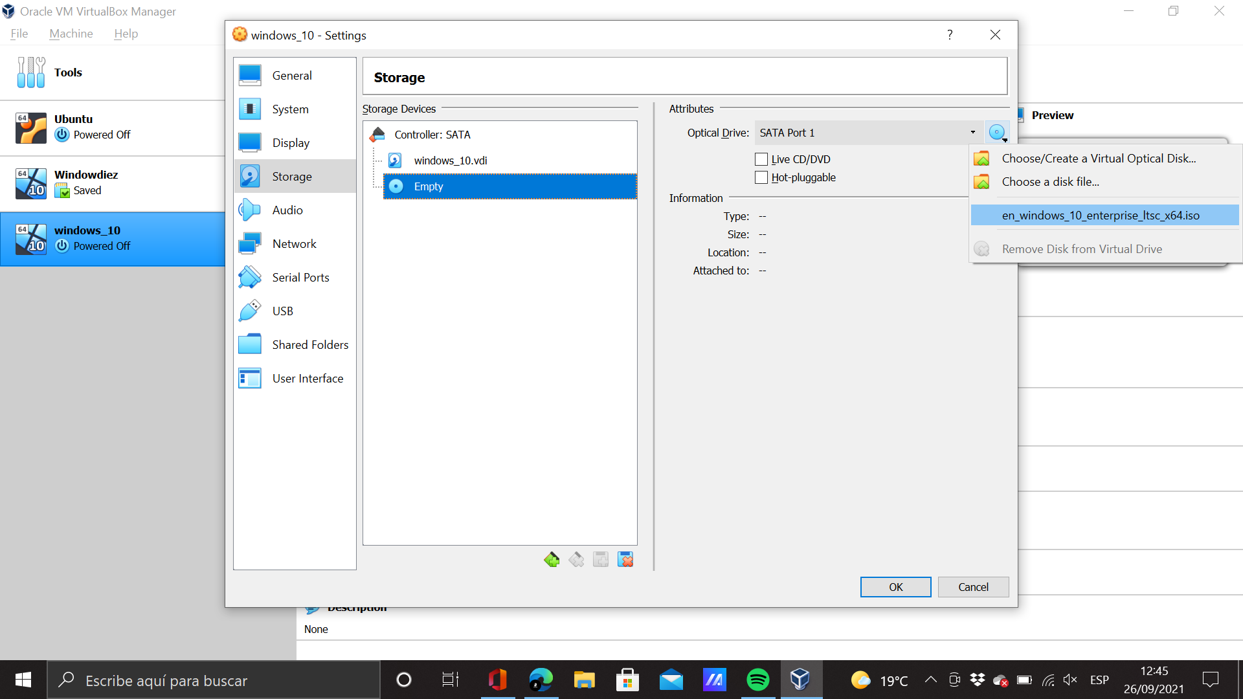Step 3 We start the virtual machine

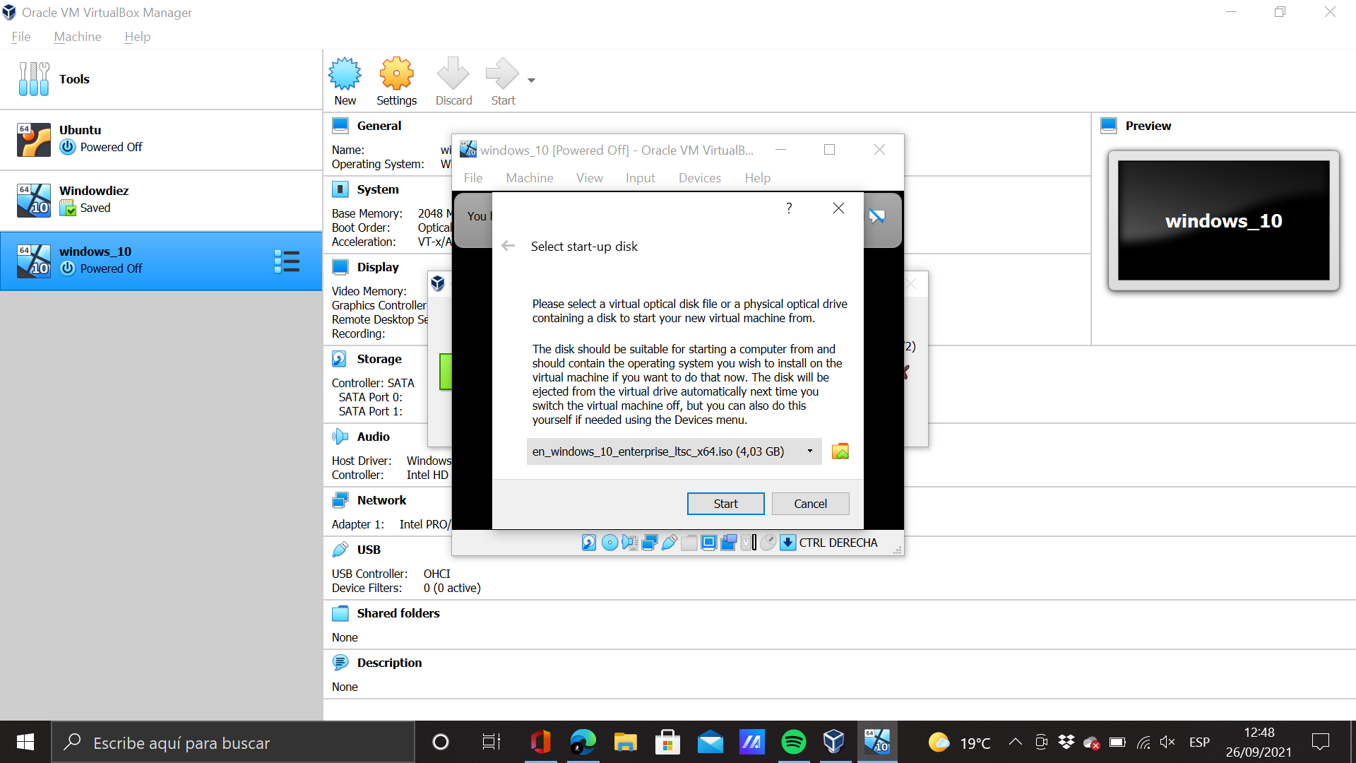

Step 4: We start the installation of windows 10.

Step 5: To add usb 3.0 support we need to download an extension pack for virtual box. After that we need to upload in the virtual machine app. To do that we go on Preference and we select Extensions

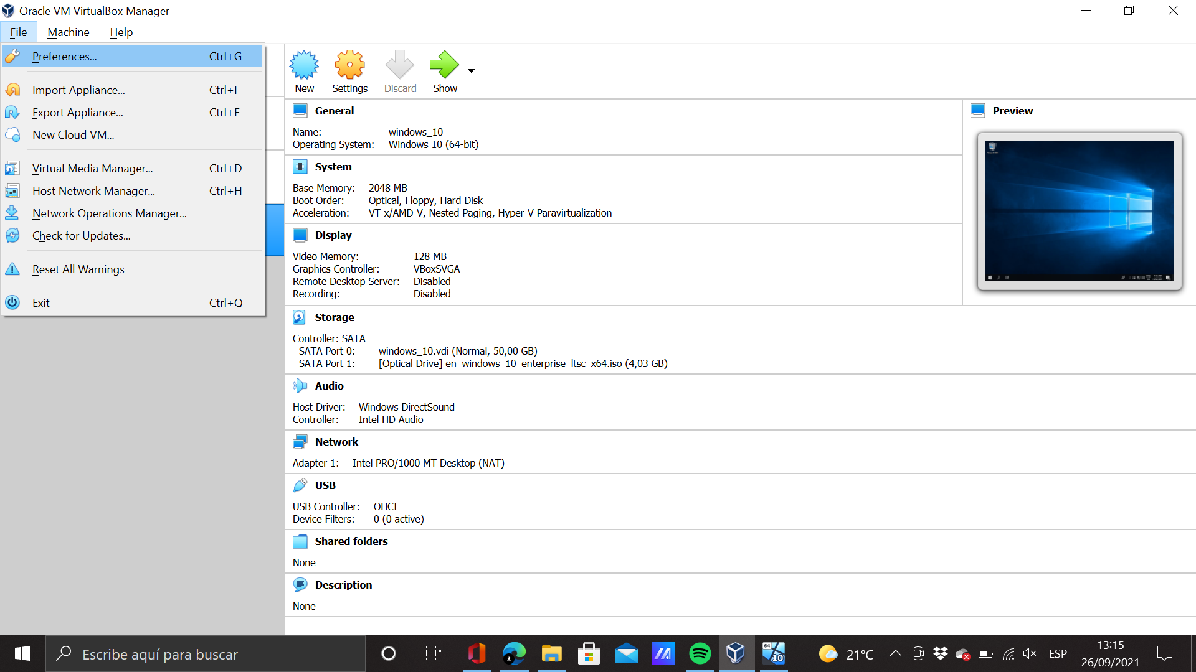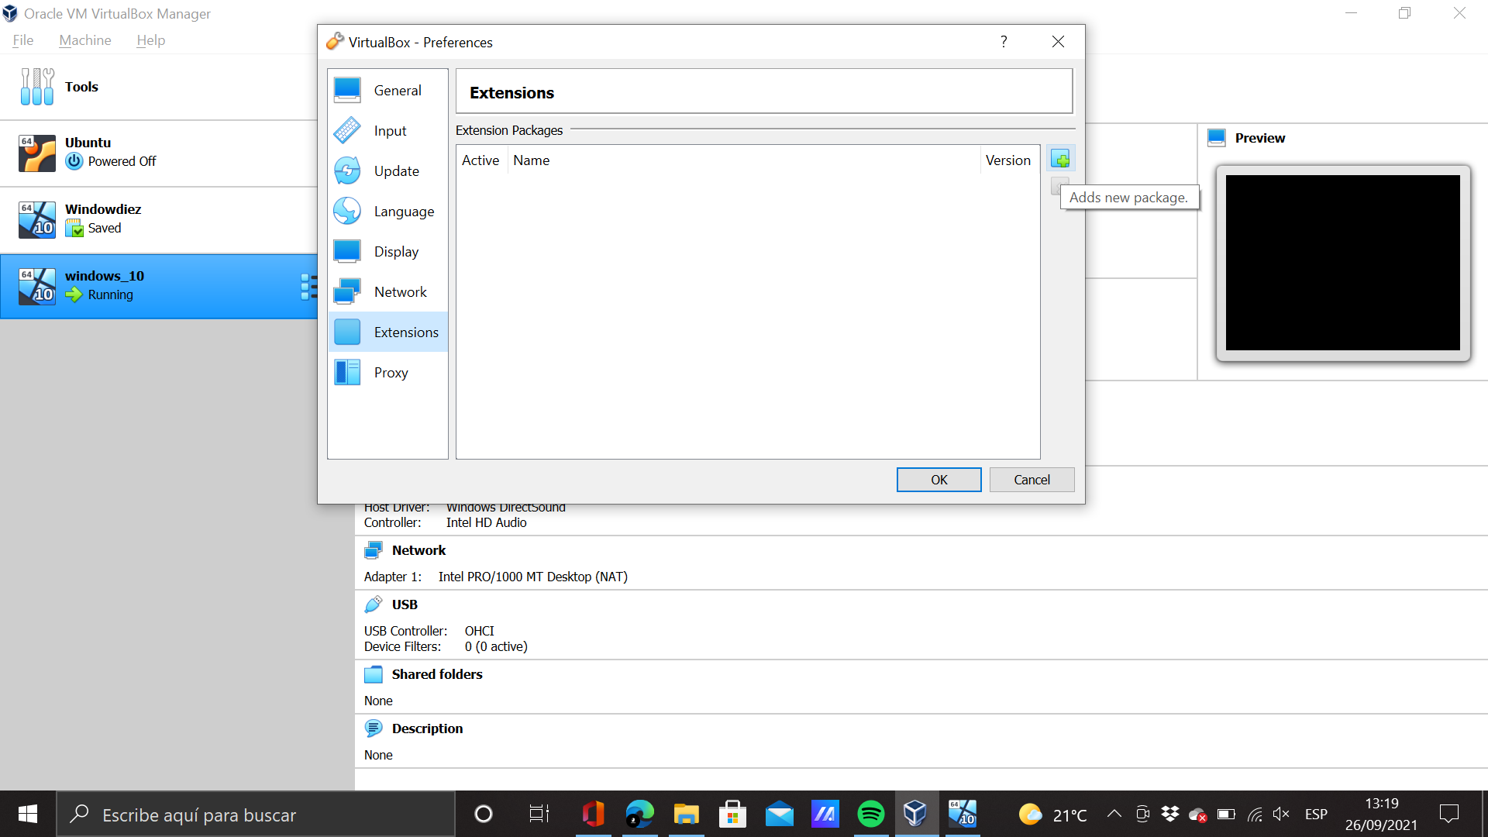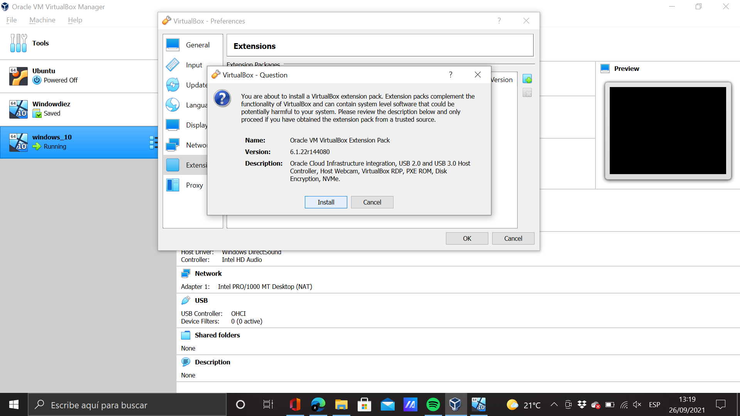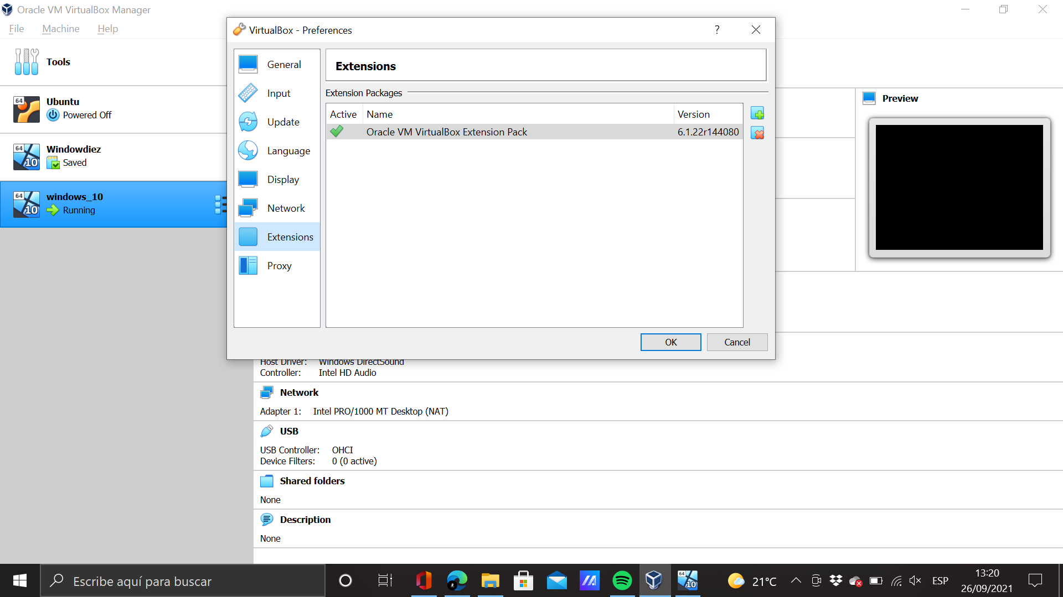After this few steps we need to shutdown our virtual machine and select Settings from our virtual machine and look for usb Setting. Now we can select usb 3.0.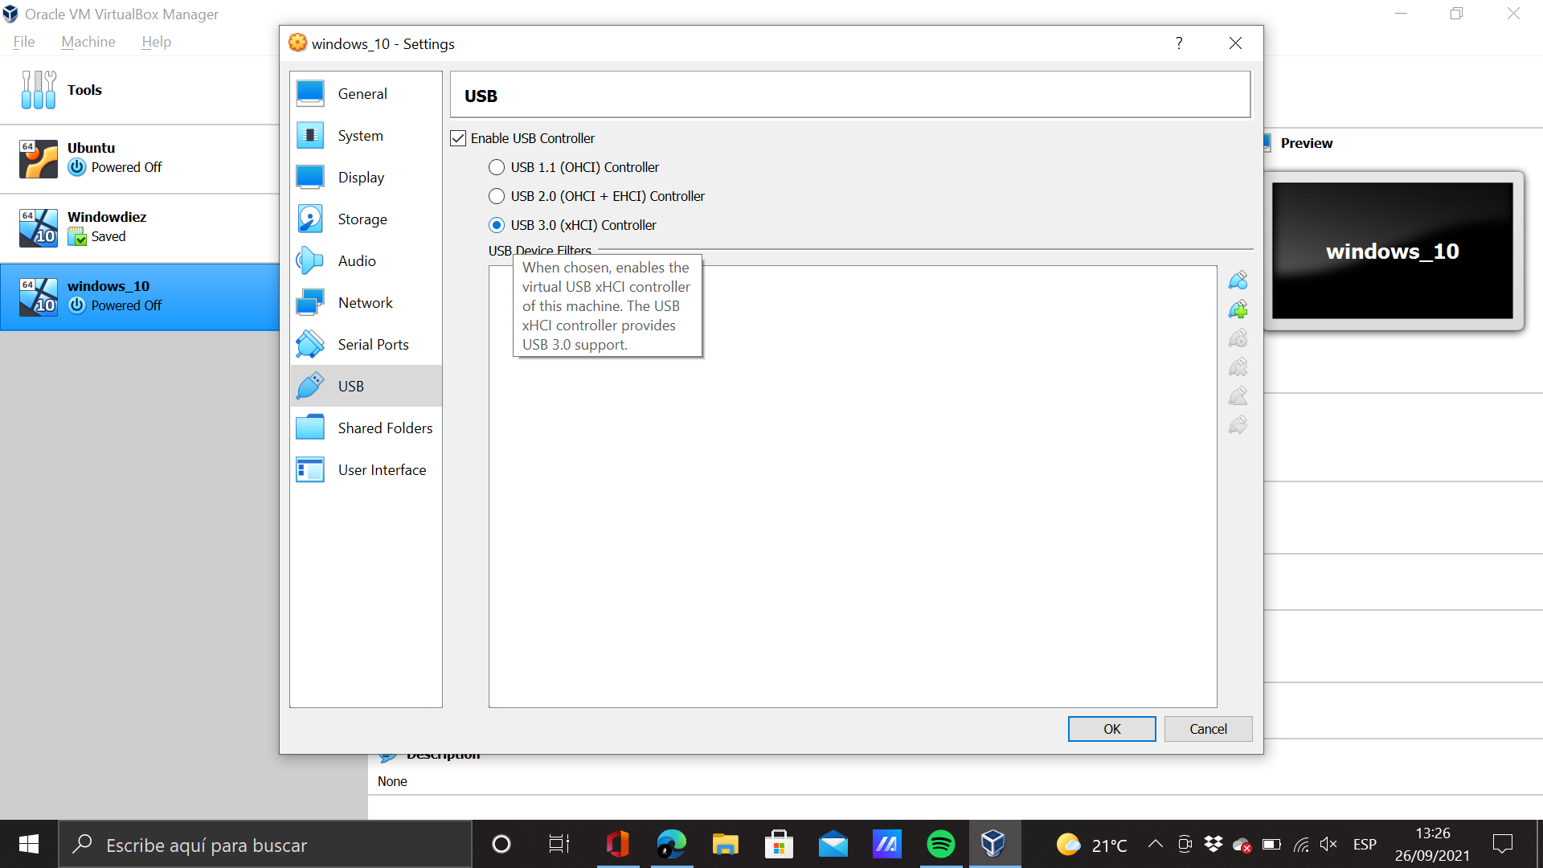For the rest of items we need to install Guest addition to use them. So we need to start our virtual machine and go to Devices and select Insert guess addiction cd file.

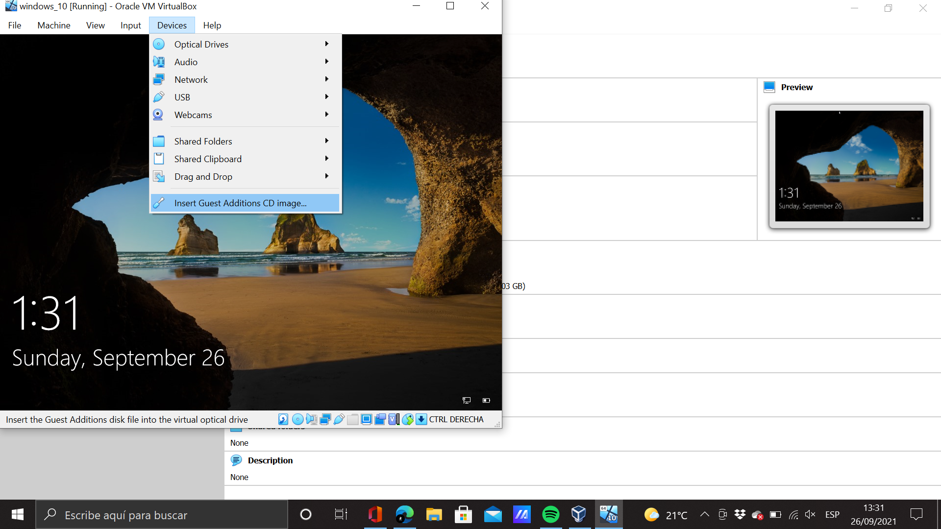We installed it and we go to This PC and install Addittions file. After that the virtual machine will be rebooted. Now we can change on Setting to shared folders, Copy and paste from the host and viceversa and have internet and connection with the network.

Step 6: We go to Setting, General, Advanced and change on shared clipboard: Bidirectional. Now we can copy and paste in a bidirectional way.

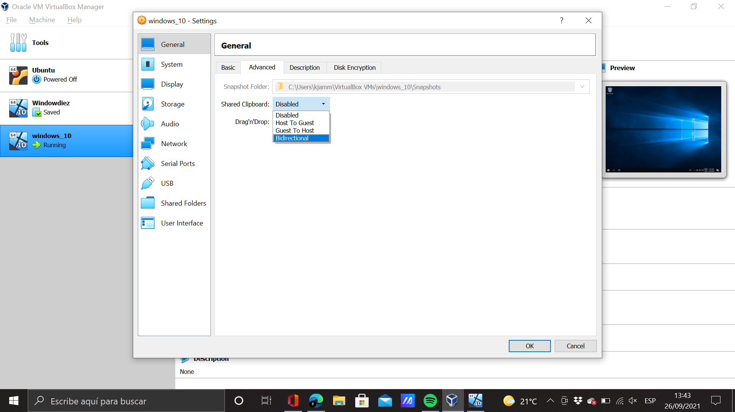

Step 7: For the internetand network connection we need to shutdown the virtual machine and go to seetings, system, and click on network

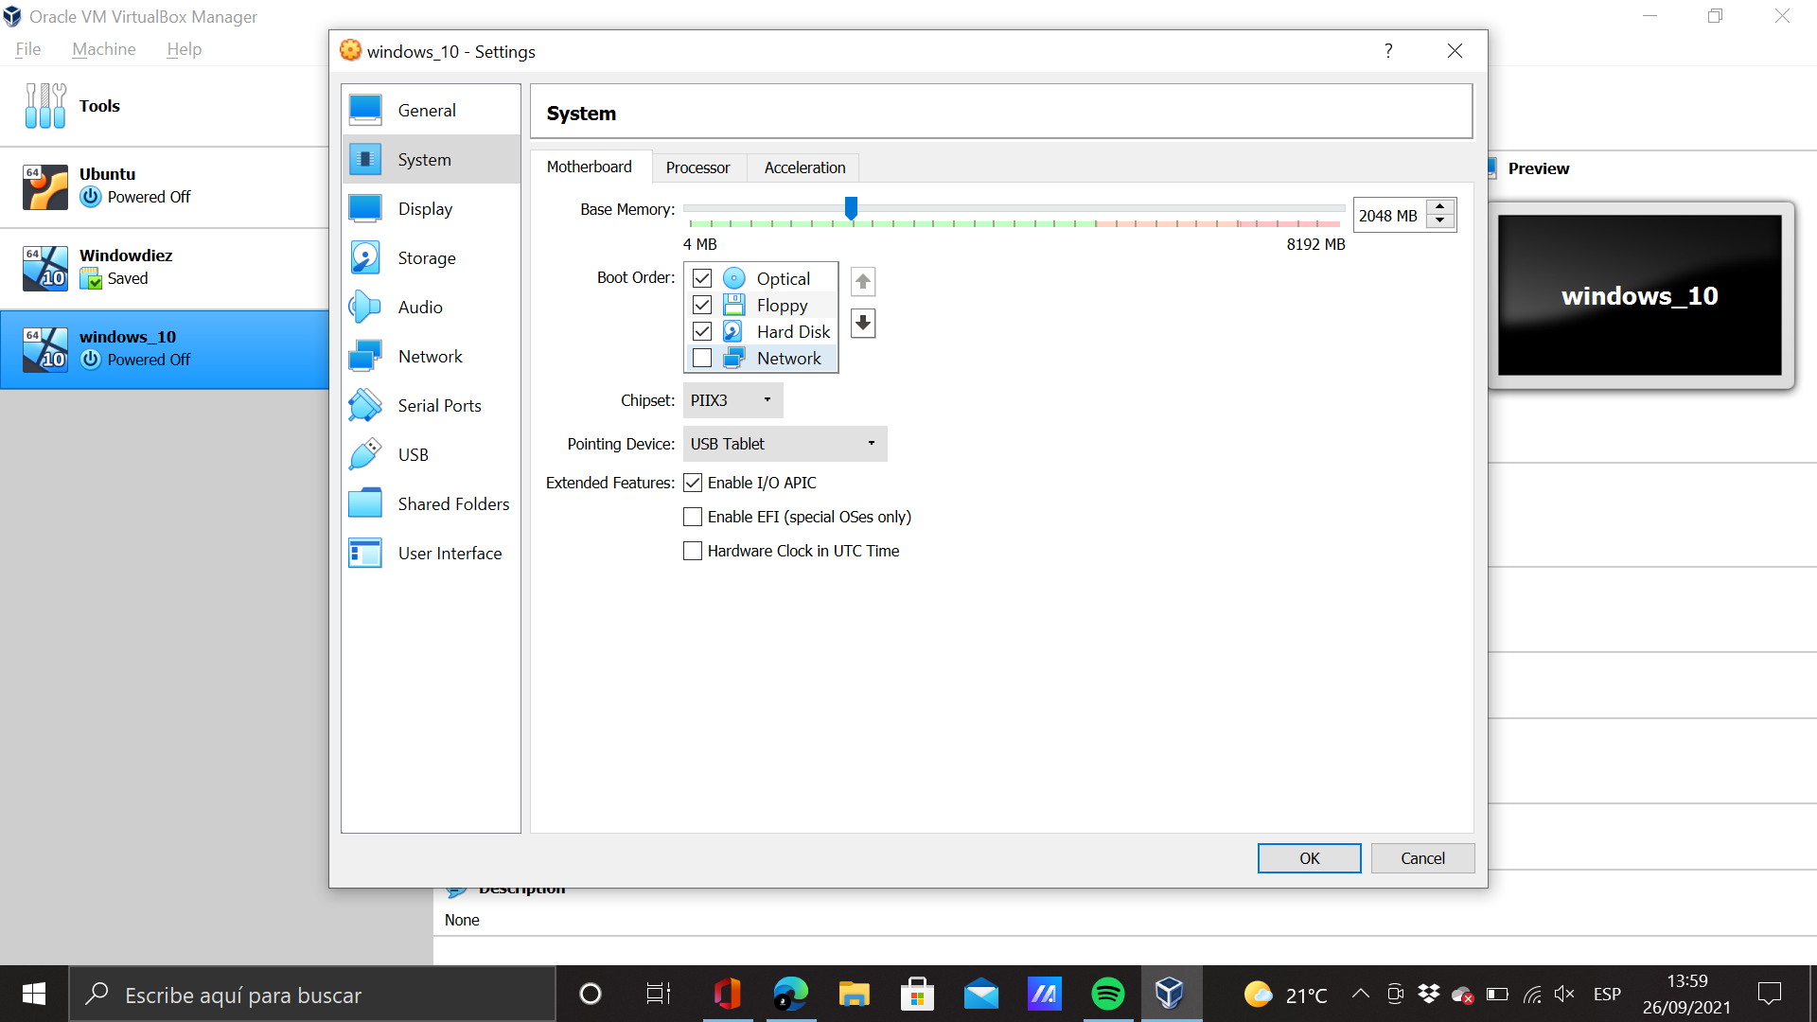Step 8: To share folder we go on This pc and click on Netwoork. We click Yes, and now we can put any folder to share.

